Access Zoom Phone Voicemails
This guide is intended to teach users and staff how to access Zoom Phone Voicemails.
1. Open a new tab in your preferred web browser and go to Arizona.zoom.us
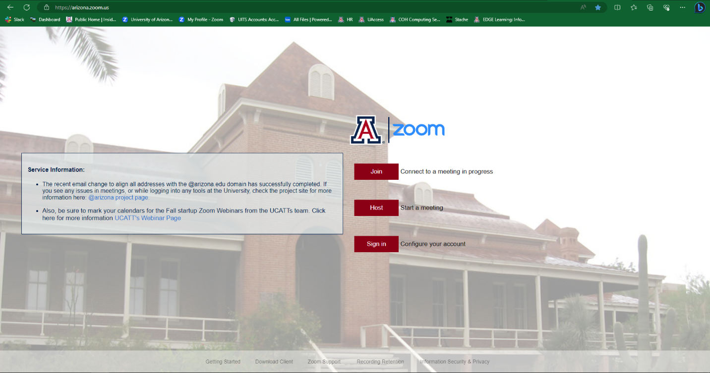
2. Click on Sign In, you will then be prompted to enter your NetID and Password
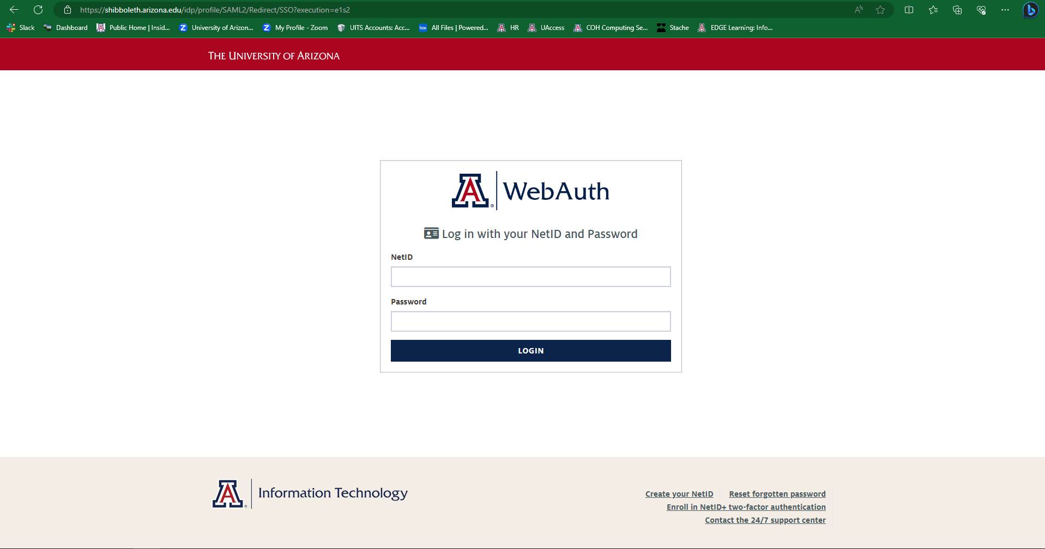

3. On the Zoom homepage, click on Phone
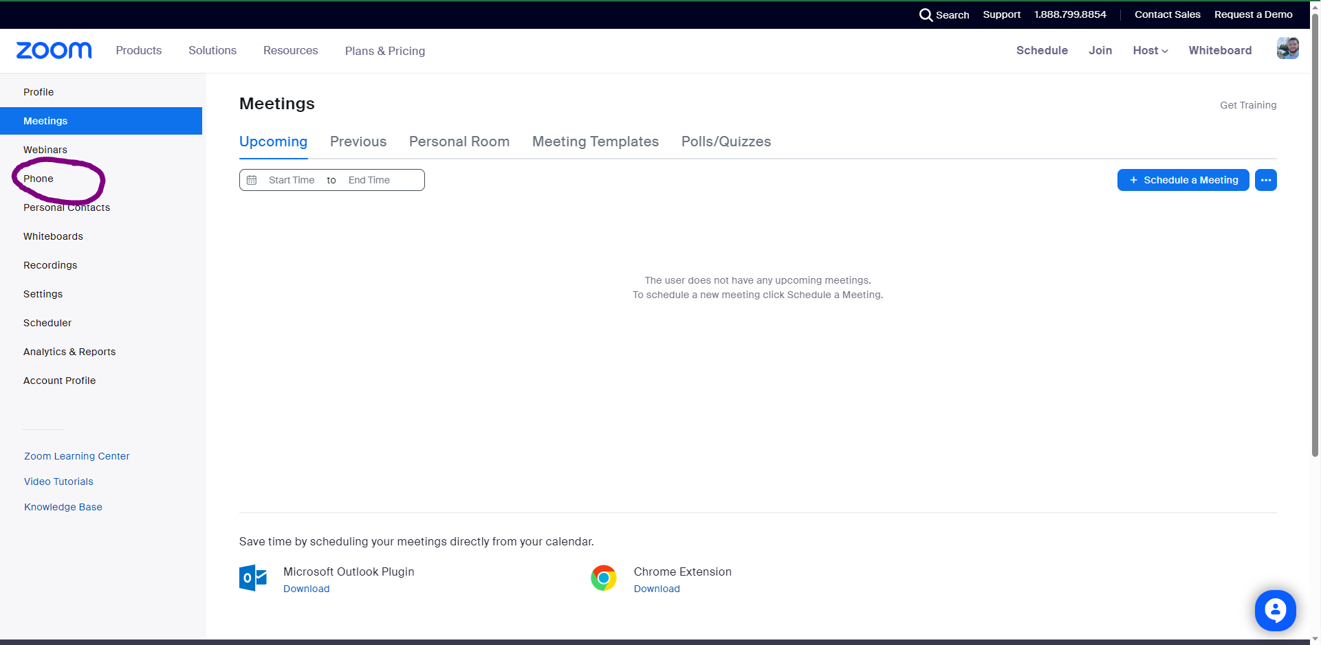
4. Then click on Voicemail; you will see your voicemails here
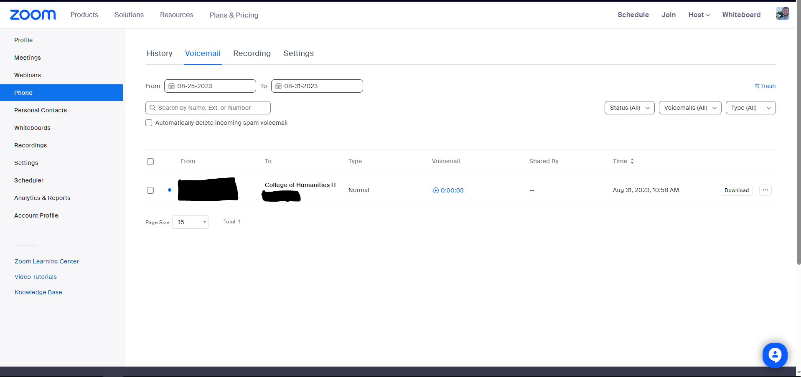

5. To hear the voicemail, click on the Timestamp
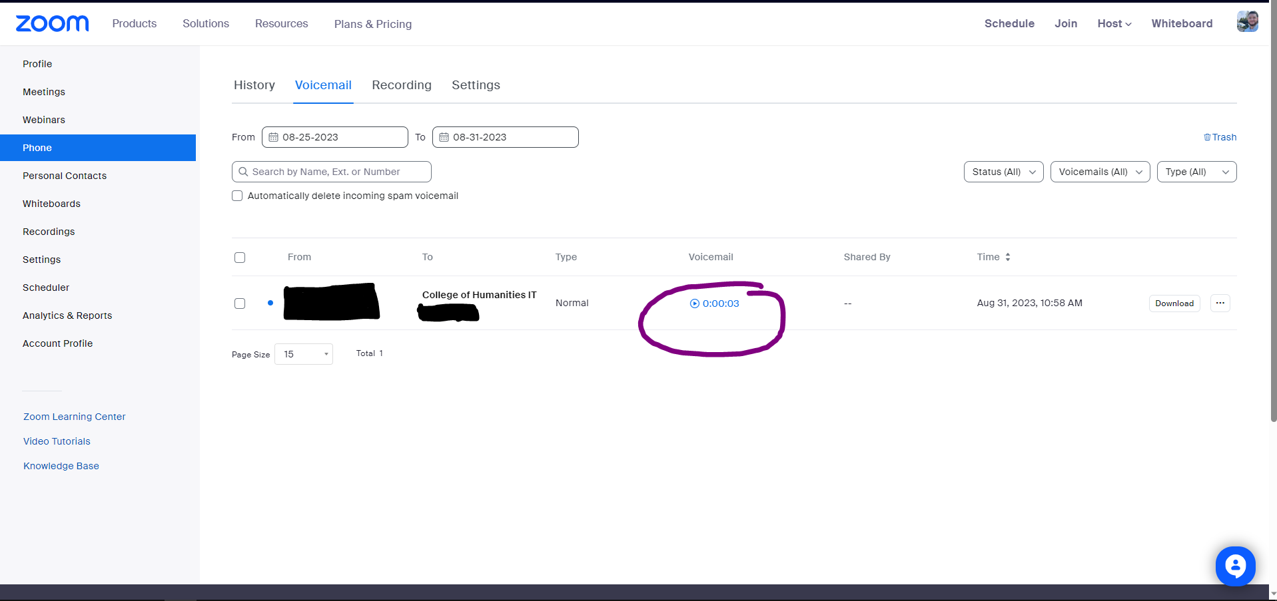
6. To download the voicemail for future reference click on Download. This will save an audio file to your device.
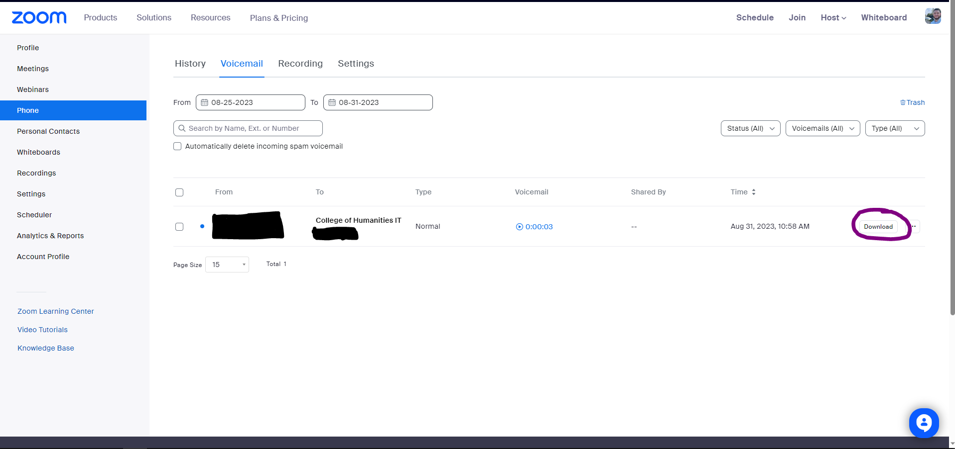
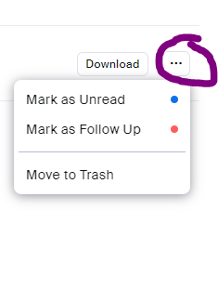
7. If you need to delete the voicemail, click on the three dots and click on Move to Trash

