Admin by Request
This guide is intended to help users understand the concept of Admin by Request and how to enable it on MacOS devices.
What is Admin by Request?
You may have noticed recently that whenever you try to make changes to your system or install new software, your university credentials do not work. Before, COH-IT would create local accounts with administrator privileges for MacOS devices. However, as we transition to a new management system provided by the University, this is not possible anymore. Users will have to manually request administrator access to their MacOS devices by using the new Admin by Request feature. This will enable users to make system changes and install software. So how do you use the new Admin by Request feature?
How to use Admin by Request
- Whenever you try to make a system change or install software, you will notice that your account credentials do not work. You should see a screen similar to this one:
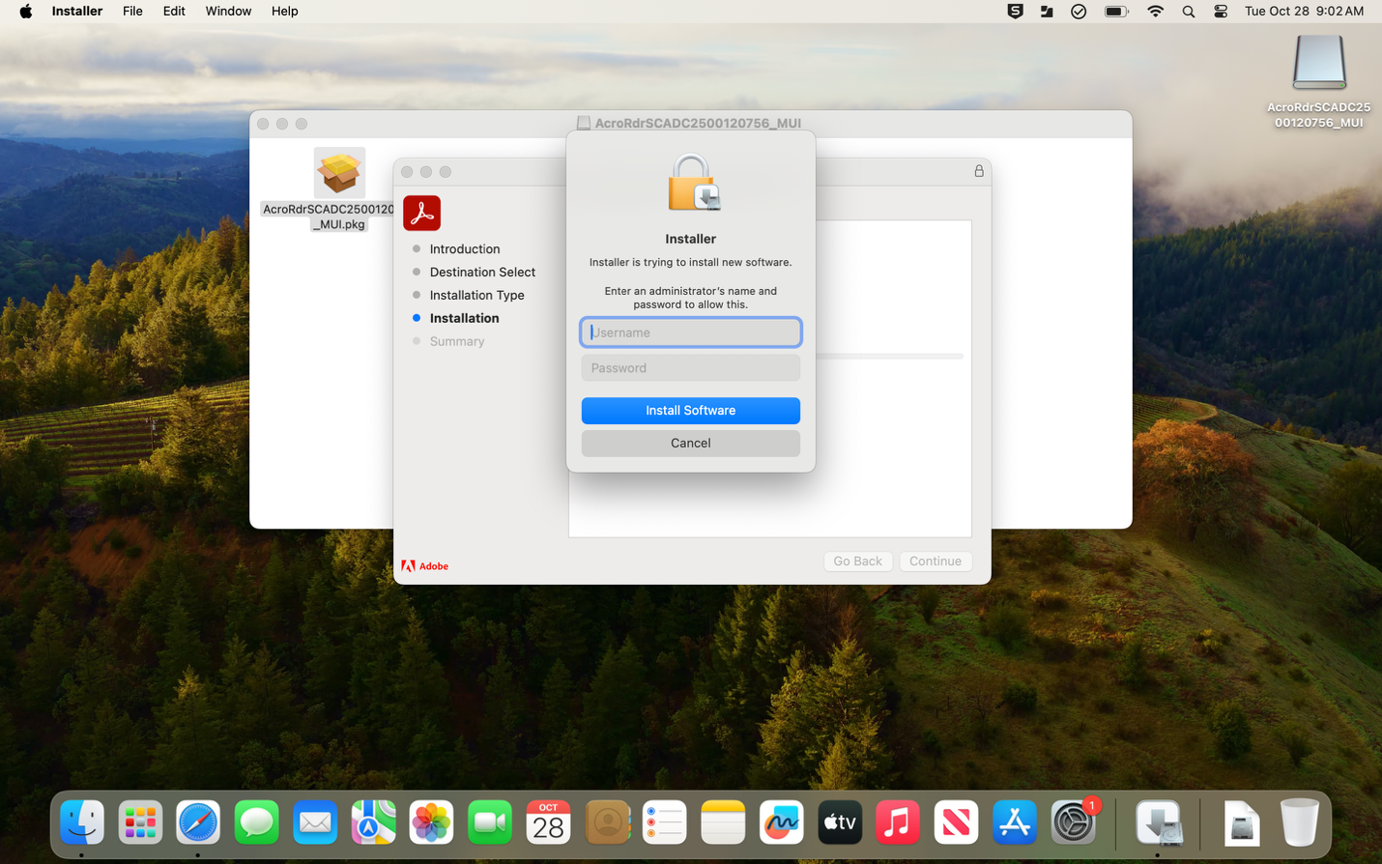

- Admin by Request runs in the background, you should notice a check mark icon towards the top right of your desktop. Click on the check mark icon and you should see “Request administrator access”. If you DO NOT see this icon, please contact COH-IT.
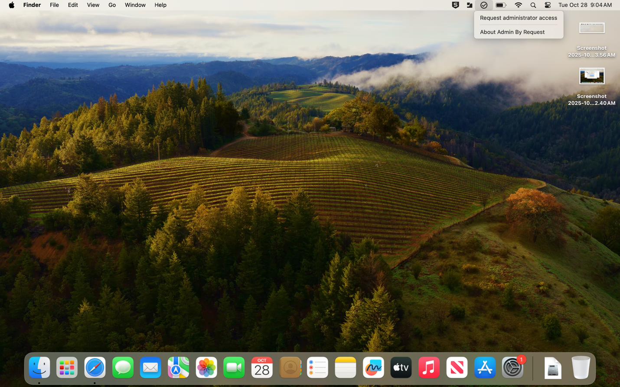
- Click on “Request administrator access”, a new window should appear
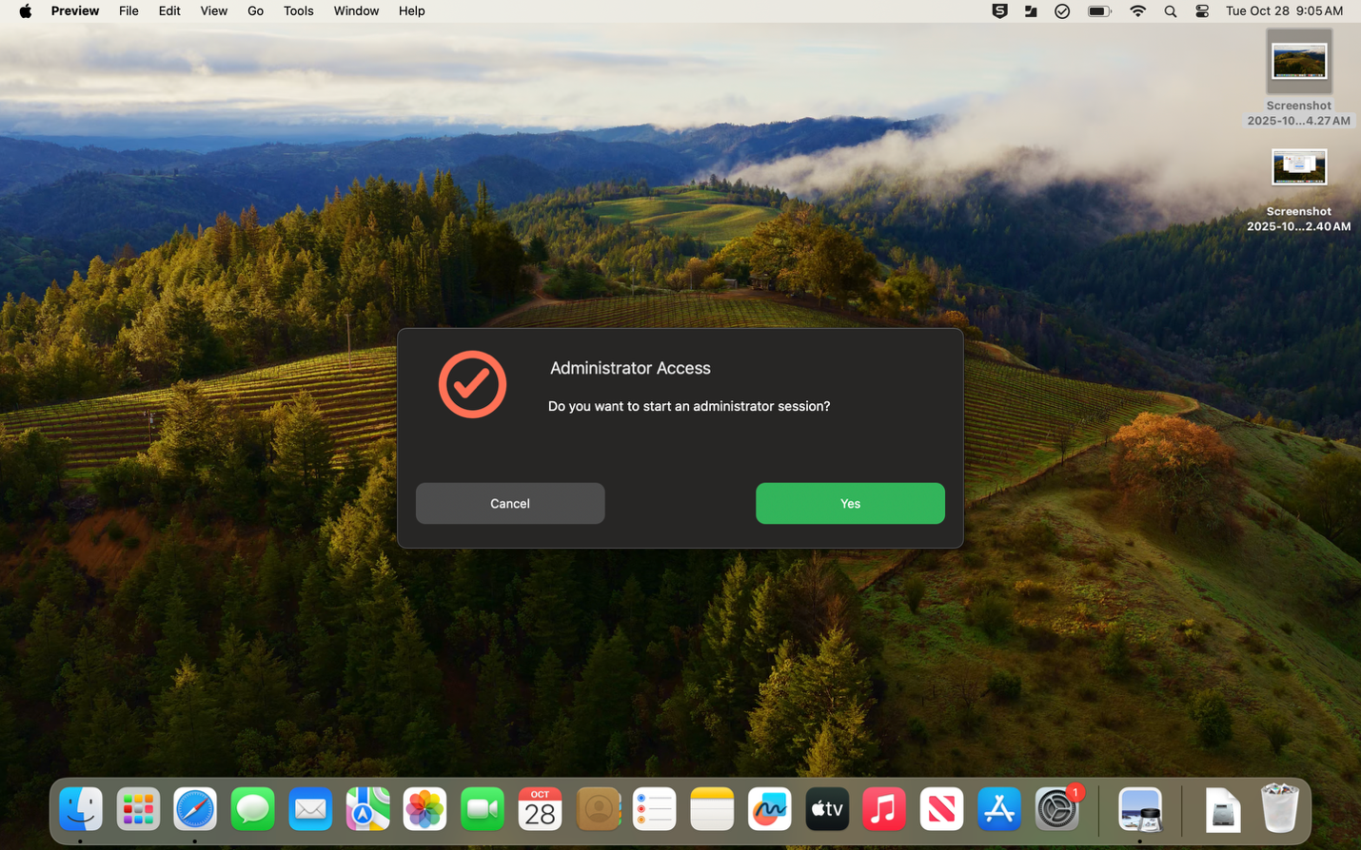

- Click on Yes, you are then required to enter a reason for why you need admin privileges. This MUST be filled out; it will not let you continue if it is blank. Then click yes.
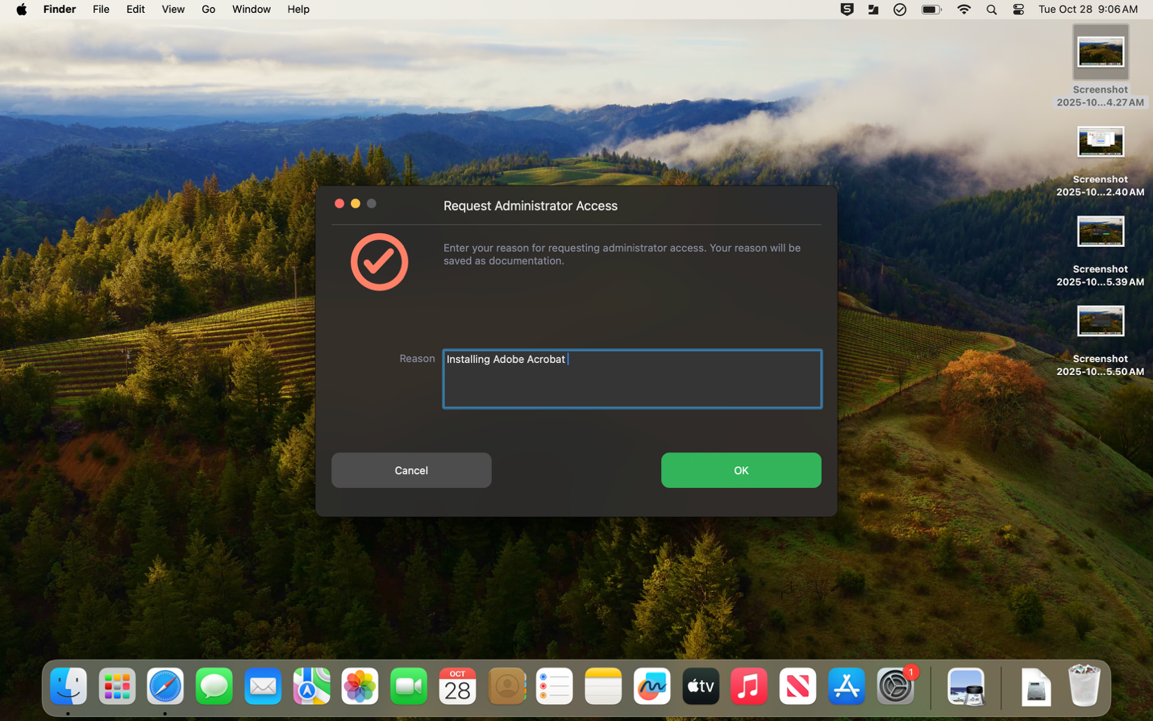
- Now you will get an hour of admin privileges. This is enough time to make whatever change you need to make or install software.
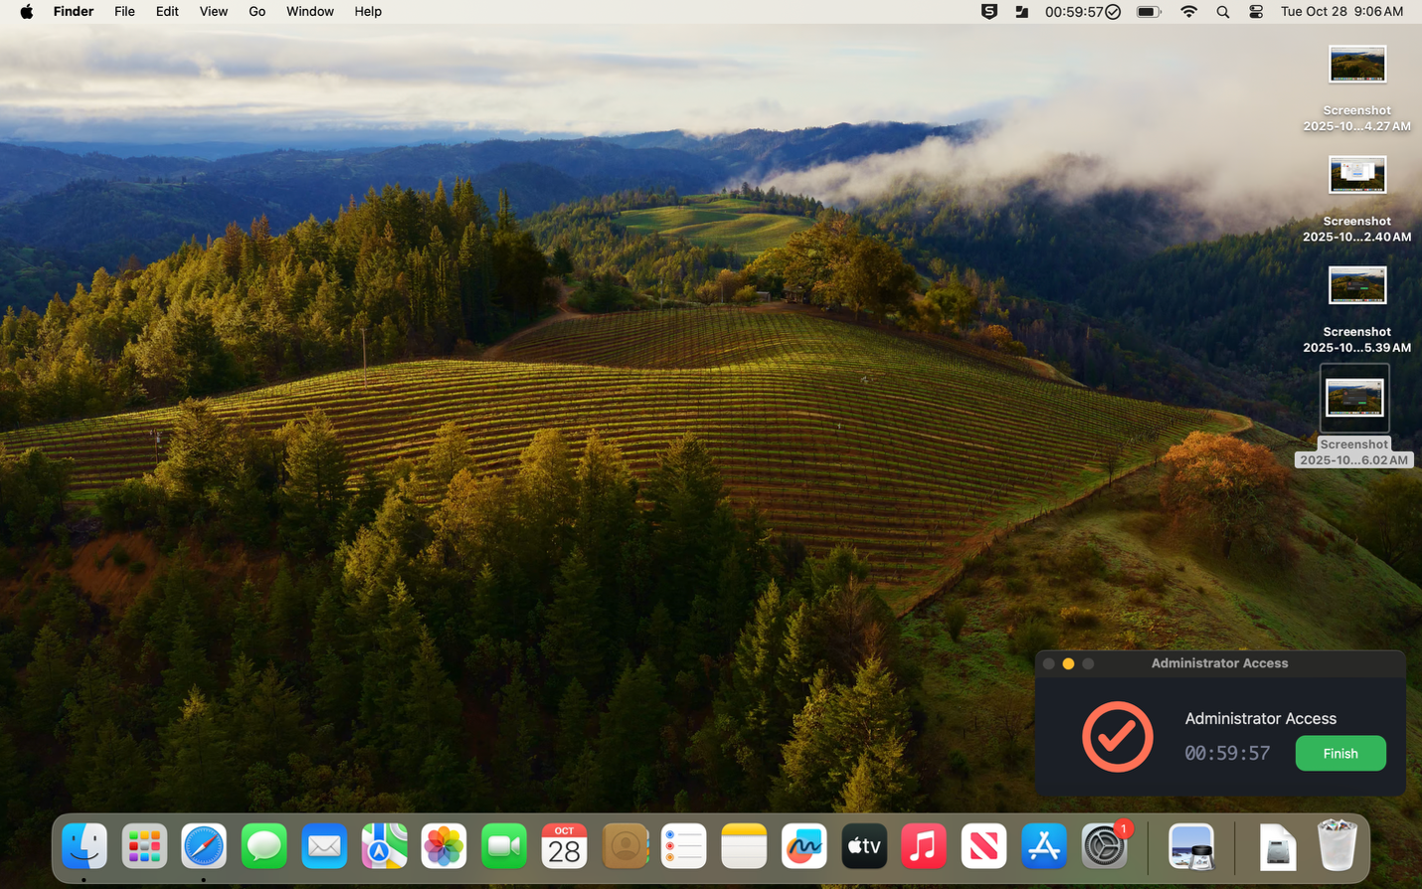

- Now that you have administrator privileges, whenever you are required to enter your credentials to make a change. Your username will automatically populate in the username field. You will need to enter your account password.
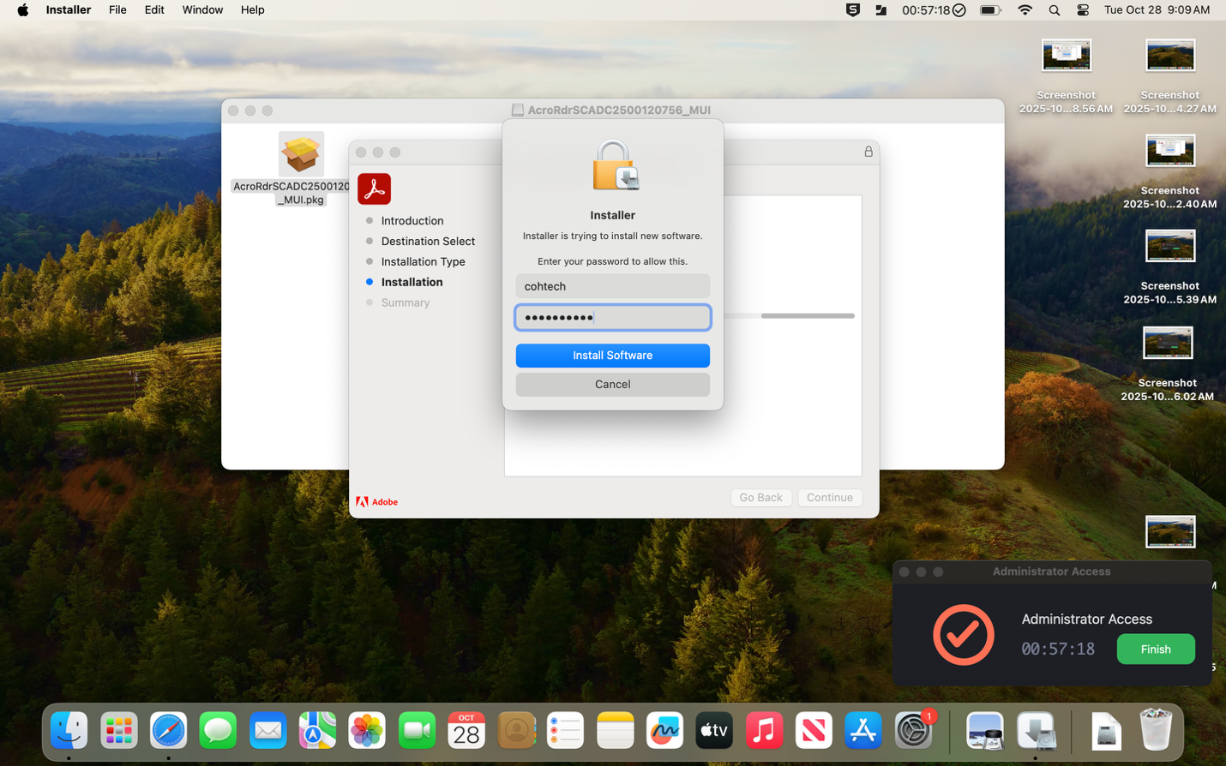
- Once you are done, just click on Finish. A new window will appear, click on yes. Congratulations, you just learned how to use Admin by Request!
